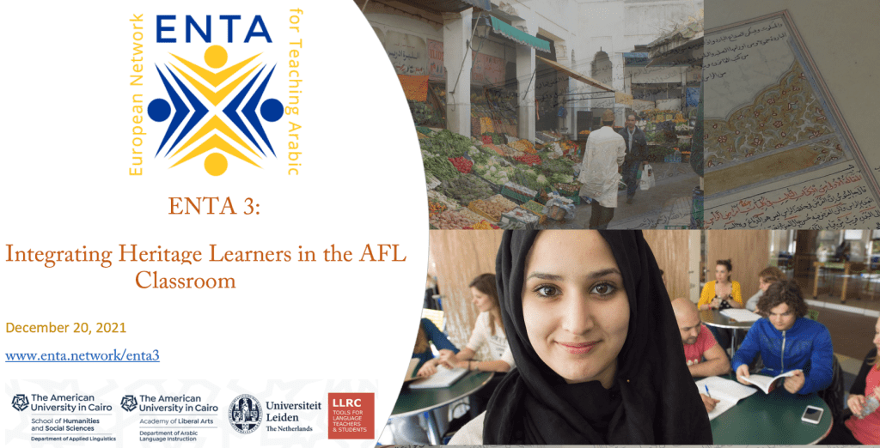
Group 1 | Group 2 | sGroup 3

Workshop evaluation link: https://leidenuniv.eu.qualtrics.com/jfe/form/SV_8oc5z0jYbJywO8u
Workshop shared document, password “AHLL” (no inverted commas).
We will use this document as our sandbox.
Participants (write your name here):

Group 1:
Food for Thought: Order the following factors in terms of their importance in effectively integrating HLs in your Arabic class (1 most important, 10 least important):
rank | factor
2 | Understanding the cultural background and motivation of the AHLs. | 😊
3 | sketching the linguistic characteristics of various types of AHLs. | 😊
1 | Anticipating the challenges facing teachers and students in an AHL classroom. | 😊
5 | Differentiating the learning experience so AHLs and L2 learners’ needs are addressed. | 😊
7 | Determining if a certain approach (e.g. PBLL) is effective in my context. | 😊
6 | Evaluating, and possibly adapting, the extent to which PBLL is used in already available course plans. | 😊
4 | Planning my own HL-oriented instructional units.
 | Access to useful HL teaching resources for Arabic or other languages.
 | Ability to reach out to colleagues interested in HLL for shared wisdom.
 | Other (please specify)

Evaluate a resource
- Pebbles (hawaii.edu)
- PBLWorks
- Own materials
Resource link: https://nflrc.hawaii.edu/pebbles/prototype/doc/51/

Does it offer potential for differentiated learning in Arabic?
- Product well-defined? Yes
- Product addresses a real-world need?
- Opportunity for collaborative learning?
- Opportunity to incorporate all skills/modes?
What we like about it:

What we do not like about it:

How we can adapt it to our context:

Design a PBLL unit for Arabic
Project Title
Background
What is the socially relevant question that the students will address by creating the project?

Task
How are the questions to be addressed in the project?

Steps
- Who are the team members/how many? What are their roles?

- What are the steps they need to make?

- Assessment
Product 1 | Points | Product 2 | Points
Content:
Language:
procedure:
Total:

Course planning:
- What is the level of the class?

- What language do the students need to be able to create the project?
  - Vocabulary:
  - Grammar:
  - Language functions:
  - Other:

- Scaffolding: what tentative resources will you use to support learning? If you cannot find links right away, write a description of what you will look for or create.

- Sequencing: how many classroom sessions will you use to support students creating the project? what will you do in each?

Group 2:
Food for Thought: Order the following factors in terms of their importance in effectively integrating HLs in your Arabic class (1 most important, 10 least important):

rank | factor
5 | Understanding the cultural background and motivation of the AHLs. | 😊
4 | sketching the linguistic characteristics of various types of AHLs. | 😊
3 | Anticipating the challenges facing teachers and students in an AHL classroom. | 😊
1 | Differentiating the learning experience so AHLs and L2 learners’ needs are addressed. | 😊
2 | Determining if a certain approach (e.g. PBLL) is effective in my context. | 😊
8 | Evaluating, and possibly adapting, the extent to which PBLL is used in already available course plans.
7 | Planning my own HL-oriented instructional units. | 😊
9 | Access to useful HL teaching resources for Arabic or other languages.
6 | Ability to reach out to colleagues interested in HLL for shared wisdom.
 | Other (please specify): Role of the dialect(s)

Evaluate a resource
- Pebbles (hawaii.edu)
- PBLWorks
- Own materials
Resource link:
Does it offer potential for differentiated learning in Arabic?
- Product well-defined?
- Product addresses a real-world need?
- Opportunity for collaborative learning?
- Opportunity to incorporate all skills/modes?
What we like about it:
- Interesting,
- can be differentiated,
- incorporates culture,
- students can show their talents and creativity
What we do not like about it:
- Time consuming (more than traditional tasks e.g. write an essay about …)
- Problems with group work in general ...
How we can adapt it to our context:
- Create a brochure for potential study-abroad students
- Students choose the country they want to work on
- Possibility: if students are in England, they can make the brochure for Arab tourists (authentic, real-world task)
Design a PBLL unit for Arabic
Project Title
Background
What is the socially relevant question that the students will address by creating the project?

Task
How are the questions to be addressed in the project?

Steps
- Who are the team members/how many? What are their roles?

- What are the steps they need to make?

- Assessment
Product 1 | Points | Product 2 | Points
Content:
Language:
procedure:
Total:

Course planning:
- What is the level of the class?

- What language do the students need to be able to create the project?
  - Vocabulary:
  - Grammar:
  - Language functions:
  - Other:

- Scaffolding: what tentative resources will you use to support learning? If you cannot find links right away, write a description of what you will look for or create.

- Sequencing: how many classroom sessions will you use to support students creating the project? what will you do in each?

Group 3:
Food for Thought: Order the following factors in terms of their importance in effectively integrating HLs in your Arabic class (1 most important, 10 least important):

rank | factor
1 | Understanding the cultural background and motivation of the AHLs. | :)
3 | sketching the linguistic characteristics of various types of AHLs. | :)
4 | Anticipating the challenges facing teachers and students in an AHL classroom. | :)
2 | Differentiating the learning experience so AHLs and L2 learners’ needs are addressed. | :)
7 | Determining if a certain approach (e.g. PBLL) is effective in my context. | :)
8 | Evaluating, and possibly adapting, the extent to which PBLL is used in already available course plans. | :)
5 | Planning my own HL-oriented instructional units. | :)
6 | Access to useful HL teaching resources for Arabic or other languages. | :)
9 | Ability to reach out to colleagues interested in HLL for shared wisdom.
10 | Other (please specify)

Evaluate a resource
- Pebbles (hawaii.edu)
- PBLWorks
- Own materials

Resource link:
Does it offer potential for differentiated learning in Arabic?
- Product well-defined? Yes, we will adapt it to a study-abroad in Cairo video travel guide
- Product addresses a real-world need? yes
- Opportunity for collaborative learning? yes
- Opportunity to incorporate all skills/modes? yes
What we like about it: It can be used for different levels, it is a real-world need that can be very useful for students/ share it on the website of the program.

What we do not like about it:

How we can adapt it to our context:
Design a PBLL unit for Arabic
Project Title
Background
What is the socially relevant question that the students will address by creating the project?

Task
How are the questions to be addressed in the project?

Steps
- Who are the team members/how many? What are their roles?

- What are the steps they need to make?

- Assessment
Product 1 | Points | Product 2 | Points
Content:
Language:
procedure:
Total:

Course planning:
- What is the level of the class?

- What language do the students need to be able to create the project?
  - Vocabulary:
  - Grammar:
  - Language functions:
  - Other:

- Scaffolding: what tentative resources will you use to support learning? If you cannot find links right away, write a description of what you will look for or create.

- Sequencing: how many classroom sessions will you use to support students creating the project? what will you do in each?

